
Customer Success Services

<HUBER>

Application Understanding Document (AUD)
for

Oracle Fusion Cloud Order Management

Version 1.0

Oracle CSS Team
Date: 8-Feb-2026

Document Version History
Version | Date | Author(s) | Reviewed By
1 | 9-Feb-26 | <Author>

Table of Contents
Document Version History 1
Introduction 3
Purpose and Scope 3
About the Customer 3
Enterprise Structure 3
Order Management 4
Process List 4
Glossary 4
Key Design Considerations 5
Order Types and Orchestration Processes 5
Orchestration Process Definitions 6
Order Header Extensible Flexfields (EFFs) 7
Order Line Extensible Flexfields (EFFs) 9
Pre-transformation Rules 10
Service Mappings and Algorithms 11
Algorithm Descriptions 11
Order Management Extensions 11
ON SAVE Extensions 11
Customer Notes Solution (Extension) 12
ON START OF SUBMISSION REQUEST Extensions 12
UI Personalization 13
Pricing Assignments 13
Customer Price Profiles and Segments 14
Pricing Additional Notes 15
Global Order Promising (GOP) and ATP 15
Process – Export Order Process (Customer Care) 16
Process Flow 16
Step 1: Create Quotation 16
Step 2: Create Standard Export Order 16
Step 3: Build Shipment in Advance 16
Step 4: Invoice Processing 16
Order and Quote Confirmation Reports 17
Weight Calculations 17

Introduction

Purpose and Scope
The purpose of this document is to:
- Describe the high-level features and configurations implemented within Oracle Fusion Cloud Order Management module for J.M. Huber Corporation.
- Provide an overview of the Oracle Fusion Order Management business processes, including sales order creation, quotation management, order fulfillment, and return order processing.
- Document the key design considerations adopted during the implementation, including orchestration processes, extensible flexfields, transformation rules, service mappings, algorithms, holds, extensions, pricing assignments, and Global Order Promising (GOP) configurations.

About the Customer
J.M. Huber Corporation (Biolchim) is a global specialty and commodity chemicals company. The company develops and supplies industrial products, specialty ingredients, and engineered materials used by a broad range of commercial customers around the world.
Modules Licensed/Implemented:
- Oracle Fusion Cloud Order Management
- Oracle Fusion Cloud Global Order Promising
- Oracle Fusion Cloud Pricing

Enterprise Structure

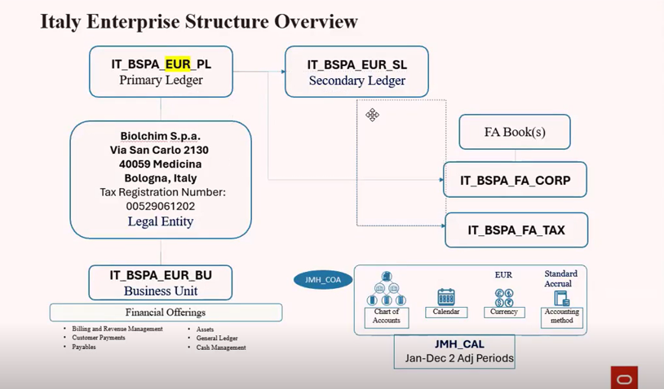
Business Unit: IT_BLCM_EUR_BU
Legal Entity: Biolchim S.p.A.

Order Management

Process List
This document covers the Order Management processes implemented for J.M. Huber Corporation. The processes covered in this document include:
Process
Customize Orchestration Process
Order Header and Line Level EFF’s
Pre-Transformation Rules
Services & Algorithm
Order Extensions
Customer Pricing Profiles and Assignments
Global Order Promising (GOP)

Glossary
Term | Definition
OM | Order Management
EFF | Extensible Flexfield
DFF | Descriptive Flexfield
GOP | Global Order Promising
ATP | Available to Promise
RMA | Return Material Authorization

Key Design Considerations
As part of the Oracle Fusion Cloud Order Management implementation for J.M. Huber Corporation, the following key design considerations have been identified and implemented:

Order Types and Orchestration Processes
Multiple order types have been configured to support different business scenarios:
Navigation: FSM > Order Management > Orders >Manage Process Assignment Rules for Sales Orders

Name | IF Condition Description | Process Name
Orchestration  Process  Assignment Rule | Order Type = Standard Domestic  Order Type = Standard EU  AND  Line Type = Buy  Line Type = Sample | CustomDOO_DOO_OrderFulfillmentGenericProcess_NoRSV
 | Order Type = Standard Export  Order Type = Sample Export  AND  Line type = Sample | CustomDOO_DOO_OrderFulfillmentGenericProcess_NoRSV_NoPause
 | Order Type = Sample Domestic  Order Type = Sample EU  AND  Line Type = Sample | CustomDOO_DOO_OrderFulfillmentGenericProcess_NoRSV_NoINV
 | Order Type = Quotation | CustomDOO_DOO_OrderFulfillmentGenericProcess_CLOSE_ONLY
Bill Only Service Items | Line type= Billy Only | CustomDOO_DOO_BillOnlyGenericProcess
RMA Orders Credit Only | Line Type= ORA_CREDIT_ONLY | CustomDOO_DOO_BillOnlyGenericProcess
RMA Orders Credit & Item | Line Type= ORA_RETURN | CustomDOO_ReturnOrder_Credit_and_Item

Orchestration Process Definitions
Navigation: FSM > Order Management > Orders >Manage Orchestration Process Definitions
Process Name | Description
CustomDOO_DOO_OrderFulfillmentGenericProcess_NoRSV | Generic fulfillment process without Reservation step. Includes a pause before invoicing to hold non-shippable lines until all shippable lines are shipped.
CustomDOO_DOO_OrderFulfillmentGenericProcess_NoRSV_NoPause | Generic fulfillment process without Reservation step and without pause before invoicing.
CustomDOO_DOO_OrderFulfillmentGenericProcess_NoRSV_NoINV | Generic process without Reservation or Invoicing steps (used for sample orders).
CustomDOO_DOO_OrderFulfillmentGenericProcess_CLOSE_ONLY | Custom orchestration with single pause step that automatically closes after 30 days (used for quotations).
CustomDOO_DOO_BillOnlyGenericProcess | Generic bill-only process for service items and credit-only returns.
CustomDOO_ReturnOrder_Credit_and_Item | Generic return order process for returns with both credit and item return.

Order Header Extensible Flexfields (EFFs)
Additional header-level fields have been configured to capture business-specific information:
Navigation: FSM > Order Management > Orders >Manage Order Extensible Flexfields

Context | Field Name
Booking Details | Booking Terms
Booking Details | Inco Destination
Booking Details | Port of Loading
Booking Details | Number of Containers
Booking Details | Port of Discharge
Customer PO Details | PO Received Date
Customer PO Details | Delay Reason
Invoice Basis | Billing Cycle
Invoice Basis | Receipt Method
Pricing Attributes | Ship to Site Number
Quote Details | Quote Reference
Quote Details | Quote End Date
Return Details | Complaint Number

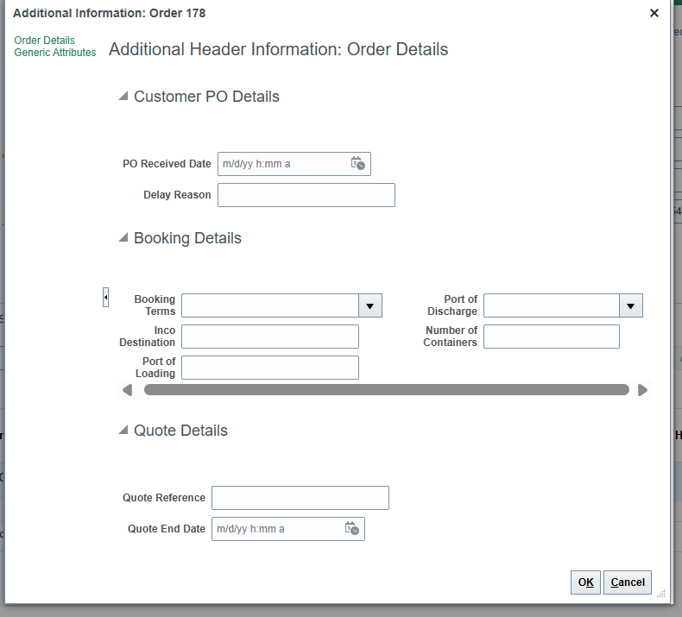
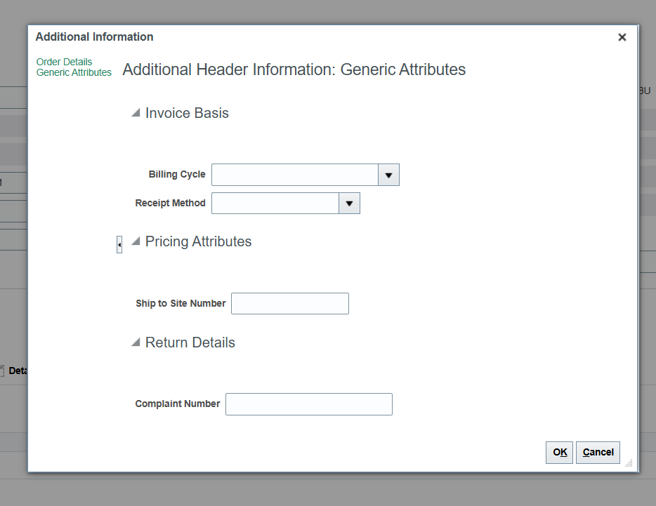

Order Line Extensible Flexfields (EFFs)
Line-level EFF fields configured for additional business requirements:
Context | Field Name
More Order Line Info | Sample Reason Code
More Order Line Info | Salesperson Commission %
Quotation Details | Quote Item Description
More Order Line Info | Original Promised Date
More Order Line Info | Original Requested Date
More Order Line Info | Prepayment Invoice Number
Return Details | Batch Number

Line Level
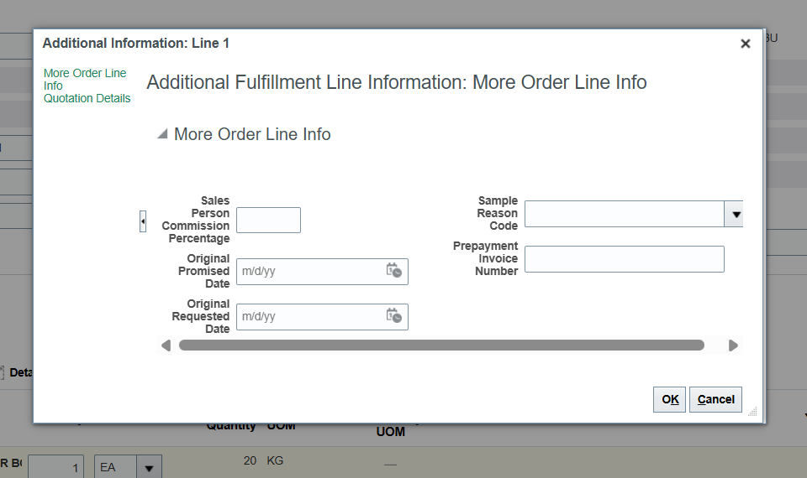
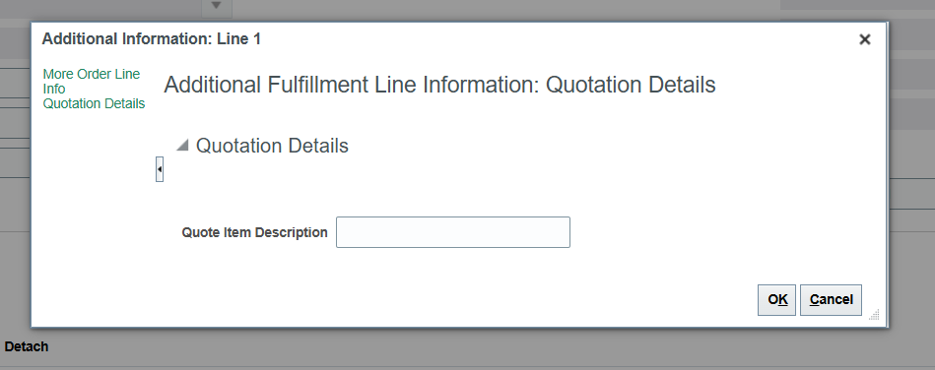

Pre-transformation Rules
Pre-transformation rules are configured to default values automatically when orders are created:
Set Up and Maintenance > Order Management > Manage Pretransformation Rules for Sales Orders
Rule Name | IF Condition | Attribute | = | THEN Value
Request Date | Requested Ship Date, Order Header is before Ordered Date.Order Header + 1 day OR Requested Ship Date, Order Header is equal to Ordered Date.Order Header + 1 day | Requested Ship Date, Order Header | = | Ordered Date + 4 days
Sample Line | Order Type = Sample Domestic OR Order Type = Sample EU OR Order Type = Sample Export | Line Type | = | SAMPLE
Split Lines - Demand Class | Customer is not blank | Allow Partial Shipments, Order Header & Demand Class, Order Header | = | No & Demand Class = -1

Service Mappings and Algorithms
Service mappings and algorithms have been configured to enable data flow between Order Management, Pricing, and Accounts Receivable:
Attribute | Service Mapping | Algorithm
Sales Commission % | OM Line EFF → AR Line DFF | Yes
Receipt Method | Header EFF → AR Header Attribute | Yes
Pricing Date | OM → Pricing Engine | No
Ship-to-Site/Order Type | OM → Pricing Strategy Assignments | Yes
FOB-based Discount | OM → Pricing Engine | No

Algorithm Descriptions
- Sales Commission % Mapping: When a sales commission percentage exists on the order line, the algorithm automatically copies it to the corresponding field on the AR invoice line.
- Receipt Method Mapping: The receipt method from the order header EFF is automatically mapped to the AR invoice header for payment processing.
- Ship-to-Site Based Pricing: Pricing strategies are assigned based on ship-to site and order type combinations to ensure correct pricing application.

Order Management Extensions
Custom extensions have been implemented to automate business processes and validations:
Navigation: FSM > Order Management > Orders > Manage Order Management Extensions

ON SAVE Extensions
Validation & Error Handling
- Ship-To Country & Order Type Validation: Validates allowed order type and customer ship-to country combinations (Domestic, EU, Export). Users receive error messages for invalid combinations.
- Business Unit Validation: Validation logic applied specifically for Biolchim Italy BU (IT_BLCM_EUR_BU).

Automated Field Defaulting
- AR Transaction Types: Defaults based on Order Type and Billing Cycle EFF (e.g., Dom Standard/Consolidated/Monthly Inv, IntraEU Standard/Consolidated/Monthly Inv, ExtraEU Standard Inv).
- Sales Order Header Attributes: Header EFFs auto-defaulted from Customer Master including Ship-to Site Number, Freight Terms, Incoterms, Port of Discharge from ship-to site, and Billing Cycle from bill-to site.
- Sales Order Line Attributes: Line-level EFFs defaulted from Item Master (Sales Commission %) and Customer Ship-to Site (Salesperson/Sales Credit).

Automatic Holds
- Invoicing Hold: Auto-applied at SO line level when Order Type = Standard Export or Sample Export.
- Prepayment Hold: Auto-applied at SO header for Payment Terms 'CIA', 'CASH ON DELIVERY', or 'IMMEDIATE'.

Customer Notes Solution (Extension)
Custom extension to automatically default customer notes to sales orders for CSR information and downstream document printing:
- Purpose: Synchronizes customer notes from customer master to sales orders based on bill-to site.
- Category Options: Delivery Document, Order Acknowledgement, Packing List, Picking List, Proforma Invoice, Quote Acknowledgement.
- Character Limit: 250 characters per record. Notes exceeding this limit are automatically split into multiple attachments.
- Functionality: Upon save, the extension reads the bill-to site, finds associated note categories, and attaches them to the sales order.

ON START OF SUBMISSION REQUEST Extensions
- Skip Credit Check for Order Type: Quotation orders skip credit check. Order revisions that don't increase amount or decrease by less than 1000€ skip credit check.
- Check Lines Box UOM Entire Quantity: Validates that finished goods are ordered in full box quantities for Buy lines. Sample lines must be in full unit quantities.
- Check Salesperson vs Customer Master: Validates that the salesperson on the order line matches the salesperson in the ship-to customer master.
- Check Supplier Drop Ship - Purchasable Item: When source supplier is entered, validates that the item is purchasable for drop ship processing.
- Check Hold for Overdue Invoices: Checks for past-due invoices or bills receivable. If found, applies hold on sales order header (for Biolchim BU and Standard order types, excluding intercompany customers as of Jan 14, 2026).

UI Personalization
User interface personalizations have been implemented through sandbox to improve user experience:

Field Visibility Adjustments
- Hidden fields: Duration, Period, Amount for Total Duration, Sales Agreement, Sales Agreement Line, Sales Agreement Version, Billing Frequency, Number of Billing Periods, Amount for Each Period, Contract Start/End Date, Project Details

Field Requirements
- Order Type: Set as Mandatory
- Pricing Date: Made visible and enabled

Field Label Updates
- Renamed 'FOB Term' to 'INCO' using UI Text Tool

Navigation Enhancements
- Added SO Report and Quote Report as tiles on the OM landing page (Springboard)

Pricing Assignments
Pricing strategy assignments are configured with the following precedence:
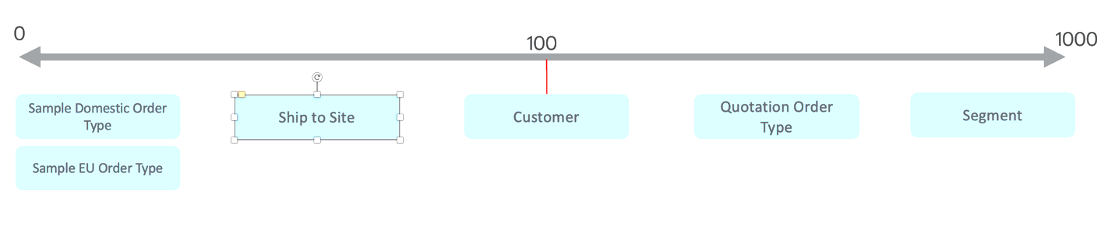

Assignment Matrix
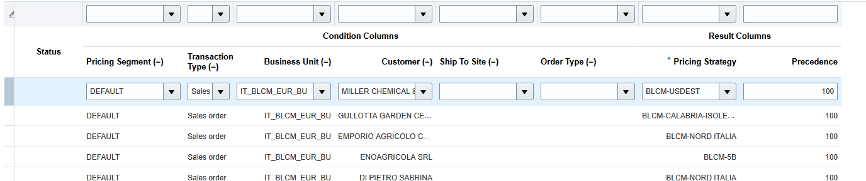

Customer Price Profiles and Segments
- Default Segment: NULL for all customer profile values or when customer pricing profile is not created
- Intercompany Segment: Customer Rating = Low. Internal customers without their own pricing strategy are assigned to the intercompany profile.

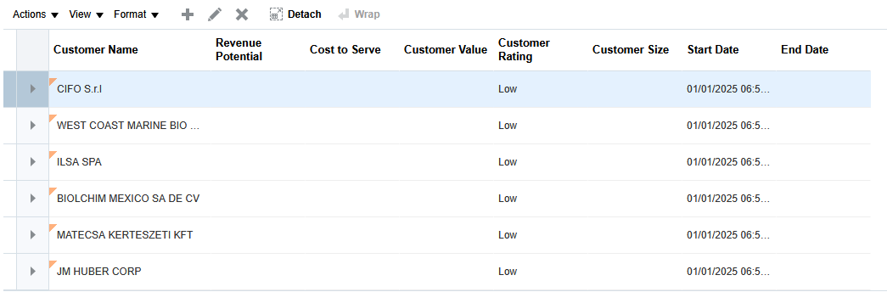

Pricing Additional Notes
- Price adjustments based on Incoterm are defined for specific price lists
- Tier-based price adjustments are configured for specific price lists
- BLCM-DEM PLAN DFLT PL: Contains all items in primary UOM pricing for revenue forecasting in planning (not used for customer transactions)
- BLCM-SAMPLE Price List: Contains lowest selling price for items used for self-invoicing
- Customer care can override prices on sales order lines for all items
- Reconciliation reports in Reports and Analytics review all pricing levels

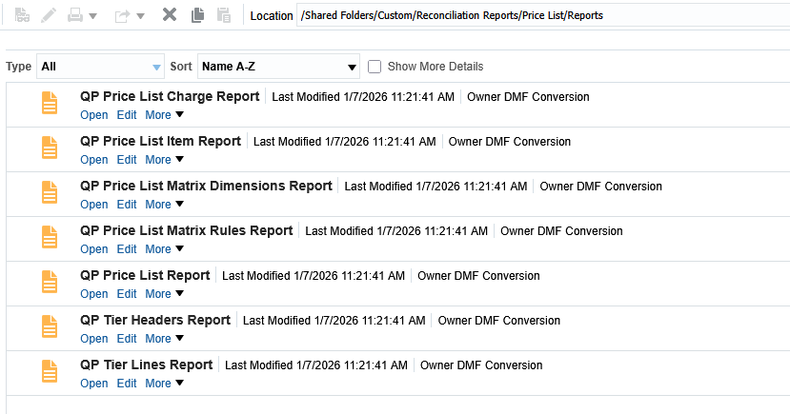

Global Order Promising (GOP) and ATP
Global Order Promising has been configured to provide accurate promise dates:

Assignment Set
- HAS Biolchim Assignment Set

Promising Catalog
- INVENTORY STRATEGY (includes MTS, MTO, DEFAULT categories)

ATP Rules
- HAS Biolchim MTS ATP Rule: Applies to MTS and DEFAULT categories with +10 working days blanket lead time
- HAS Biolchim MTO ATP Rule: Applies to MTO category with +20 working days blanket lead time

Sourcing Rules
- Assigned at three levels: Category, Category and Region, Item
- 111 item-specific assignments, including 3 sourced from supplier
- For Standard-Export orders, customer care manually selects the source warehouse during order creation

Note: GOP implementation is limited in scope. Future enhancements can include additional supply considerations in ATP rules and more accurate lead times at item/category level. Raw materials can occasionally be sold on customer orders, which is why the Default category is assigned to the MTS rule.

Process – Export Order Process (Customer Care)

Process Flow
The Export Order Process for Customer Care follows these sequential steps:

Step 1: Create Quotation
- Create a Sales Order with Order Type = Quotation
- Add items, freight charges, and additional information
- Generate the Quote document to share with the customer
- Upon customer acceptance, submit the Quote
- The Quotation Order automatically moves to close after 30 days and becomes non-editable

Step 2: Create Standard Export Order
- Create a Standard Export order by copying from the Quote order
- Add the quote reference number in header additional information
- Confirm order details and select the source warehouse
- Review header additional information
- Submit the order
- Generate the sales order confirmation report

Step 3: Build Shipment in Advance
- Build the shipment in advance in Inventory
- Create a shipment and add associated sales order lines
- Print Packing List 1 (used for booking request to freight forwarder for ocean shipment)

Step 4: Invoice Processing
- Once shipped, Export sales order lines are placed on invoice hold
- CSR selects which lines to release to invoicing (to be invoiced together)
- CSR releases the hold on selected lines
- Lines progress to 'Awaiting Billing' status
- Run the invoicing process for the sales order

Order and Quote Confirmation Reports
Custom reports have been developed for order and quote confirmations with specific business requirements:

Weight Calculations
- Net Weight = Number of EAs × Gross Shipping Weight (from Item Master)
- Gross Weight = Number of EAs × Physical Attributes: Unit Weight (from Item Master)

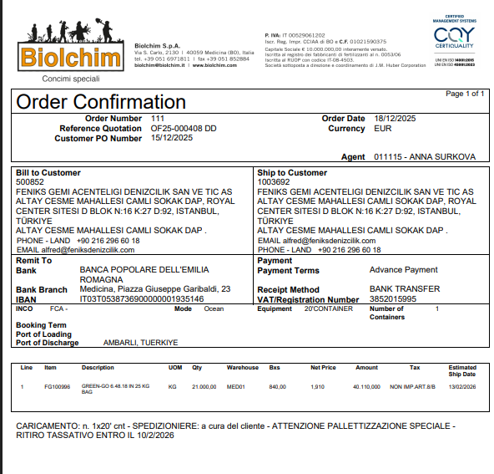

Open Points

ID | Topic | Question | Answer | Status
1 | Export vs Domestic Orders | Why are export orders handled differently from domestic orders? | Domestic orders follow a standard flow: order booking → picking → shipping → invoicing. Export orders are different because they start with a quotation, unlike domestic orders. | Closed
2 | System Integration | Is there any Salesforce or CPQ system integrated with Order Management? | No. There is no Salesforce or CPQ ecosystem integrated. Because of this, quotations and sales orders are not tightly coupled in the system. | Closed
3 | Quotation Reference | When converting a quotation to a sales order, how is the reference maintained? | Since there is no serial quotation functionality, a workaround is used: the quotation number and quotation end/expiry date are manually captured at either the sales order header or line level. | Closed
4 | Quotation Expiry | What happens if a quotation has an expiry date and changes are made after expiry? | If the quotation is expired, any changes made after the expiry date will NOT integrate into the sales order. | Closed
5 | Quote–Order Linkage | Are quotation and sales order tightly linked in the system? | No. They are not tightly coupled. The linkage exists only as a manual reference captured in the sales order because Order Management does not have seeded functionality for this scenario. | Closed
6 | Post-Conversion Changes | If the customer requests changes after quotation conversion, can those changes be made directly? | Yes, but only on the sales order, not on the quotation—once the quotation is converted. | Closed
7 | Quote Change Restriction | Why can't changes be made on the quotation after conversion? | Once converted, the quotation line status is closed after 30 days and it has already been sent for customer acceptance. Further changes must be made on the sales order, which becomes the official document. | Closed
8 | Change Window | Is there any time window to make changes to the quotation? | Yes. There is a 30-day time frame during which quotation changes are allowed before conversion. After that, changes must be handled in the sales order. | Closed
9 | Process Ownership | Who handles this quotation-to-sales-order process? | The Customer Service team manages this process and ensures the quotation is finalized first and then converted to a sales order. | Closed

